**Neighborhood of Baltimore: People, Crime, and Venues**

4/09/2020, CJRR

# 1. Introduction:

1.1: Objective:

Characterize Baltimore’s neighborhoods in terms of their crime rates, age of the residents, population density, median household income, and venues.

## 1.2: Background:

**Client:** The principle client for this is project is Jane New Resident. She is a 38-year-old female professional who is moving to Baltimore. To start her house hunt, she is looking to identify low crime neighborhoods, with grocery stores, shops, restaurants and other professionals.

**Baltimore:** Nicked named “Charm City, Baltimore is the most populous city in Maryland. It is home to the world-renowned Johns Hopkins University and Hospital and numerous tourist destinations including the Pimilico Race Course, the Inner Harbor, and the Maryland Science Center. However, crime in Baltimore far above the national average and the city has a practically high murder rate. The city is divided into nine geographic regions and over 50 neighborhoods: each neighborhood having its own character. The city’s crime generally concentrated in the neighborhoods with high rates of poverty. [1]

## 1.3. Analytic Approach:

To help Jane select neighborhoods to house hunt in, this analysis will collect and generate summary data on the crime, number and type of venues, median income, age, and household size, for each neighborhood. It will then cluster the neighbors, summarize each cluster and display the information in an interactive map. This will allow Janes review the character of each cluster and selects a subset of neighborhoods to start searching in.

# 2. Data:

2.1 Data Requirements:

The analysis describes in 1.3 will require the following data:

* List of the neighborhoods in Baltimore
* The geographic boundaries of the neighborhood
* General crime statistics for each neighborhood
* General demographic statistics for each neighborhood
* Venue information for each neighborhood

The client wants to understand the general character of neighborhoods so she can start house hunting. She is worried about the crime rate. The analysis will need to include an overall picture of the crime rate of each neighborhood.

She is looking to live near other like-professionals – a factor that is not easy to characterize. However demographic information may help identify those neighborhoods – specifically by examining the median income, the average household size, and the percentage of people that are in the 25 to 64-year-old age group. Because the crime rate is related to the high poverty areas, the analysis will include that as well.

She is interested to understand the character of neighborhoods in term of the available shopping and restaurants. For each neighborhood a listing the type and number of nearby venues will be used.

There are over 50 neighborhoods in Baltimore. The client wants to consider them in like character cluster so that she does not over constrain her house hunting options.

## 2.2 Data sources:

2.2.1 Crime and Safety:

2015 Crime and Safety data for Baltimore City is available on Data.gov here:

<https://catalog.data.gov/dataset/crime-and-safety-2015>

This data set represent the year 2015 values for Crime and Safety from Vital Signs published by the Baltimore Neighborhood Indicators Alliance. For more information, please visit http://www.bniajfi.org/vital_signs.

The crime statistics are organized by neighborhood includes the following features:

* Part 1 Crime Rate per 1,000 Residents
* Violent Crime Rate per 1,000 Residents
* Property Crime Rate per 1,000 Residents
* Juvenile Arrest Rate per 1,000 Juveniles
* Juvenile Arrest Rate for Violent Offenses per 1,000 Juveniles
* Juvenile Arrest Rate for Drug Offenses per 1,000 Juveniles
* Rate of 911 Calls for Service for Shootings per 1,000 Residents
* Rate of Gun Homicides per 10,000 Residents
* Rate of 911 Calls for Service for Common Assaults per 1,000 Residents
* Rate of 911 Calls for Service for Narcotics per 1,000 Residents
* Rate of 911 Calls for Service for Auto Accidents per 1,000 Residents
* Adult Arrest Rate per 1,000 Adults

For this analysis, of the above options, the following statistics will be included:

* Part 1 Crime Rate per 1,000 Residents
* Violent Crime Rate per 1,000 Residents
* Property Crime Rate per 1,000 Residents

Example:

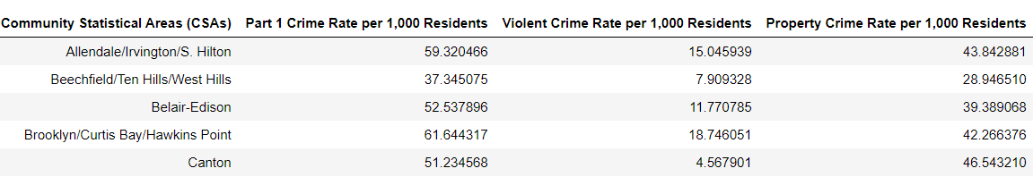

2.2.2 **Demographics:** 2015 Census demographics data for Baltimore City is available on Data.gov here:

<https://catalog.data.gov/dataset/census-demographics-2015>

This data set represent the year 2015 values for Census Demographics from Vital Signs published by the Baltimore Neighborhood Indicators Alliance. For more information, please visit <http://www.bniajfi.org/vital_signs>.

The demographics statistics are organized by neighborhood and includes the following features:

* Percent of Residents - Black/African-American
* Percent of Residents - White/Caucasian Percent of Residents - Asian
* Percent of Residents - Two or More Races
* Percent of Residents - All Other Races
* Percent of Residents - Hispanic Racial Diversity Index
* Percent of Population Under 5 Years Old
* Percent of Population 5-17 years old
* Percent of Population 18-24 years old
* Percent of Population 25-64 years old
* Percent of Population 65 years and over
* Total Number of Households
* Percent of Female-Headed Households with Children Under 18
* Percent of Households with Children Under 18
* Average Household Size
* Median Household Income
* Percent of Households Earning Less than $25,000
* Percent of Households Earning $25,000 to $40,000
* Percent of Households Earning $40,000 to $60,000
* Percent of Households Earning $60,000 to $75,000
* Percent of Households Earning More than $75,000
* Percent of Family Households Living Below the Poverty Line
* Percent of Children Living Below the Poverty Line

For this analysis, of the above options, the following statistics will be included:

* Percent of Population 25-64 years old
* Average Household Size
* Median Household Income
* Percent of Family Households Living Below the Poverty Line

Example:

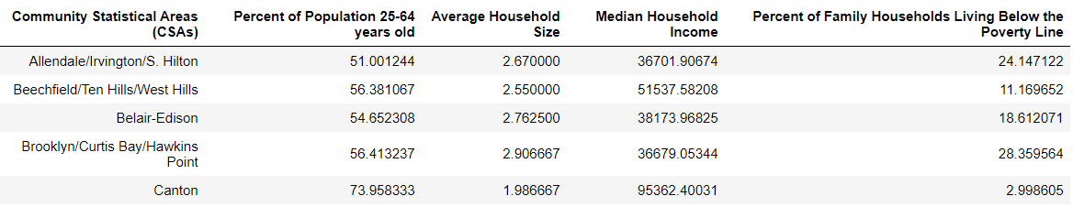

2.2.3 **Neighborhoods and Boundaries:**

Both the demographics and crime data sets include a list of neighborhoods names and geographic boundaries. See below for a map of Baltimore Community Statistical Areas, hereafter referred to as neighborhoods, and the centroid of each neighborhood:

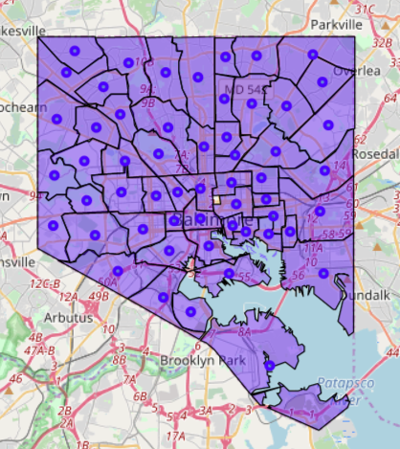

2.2.4 **Venues types and Counts:**

Foursquares will be used to generate a list of venues near each neighborhood’s center.

. 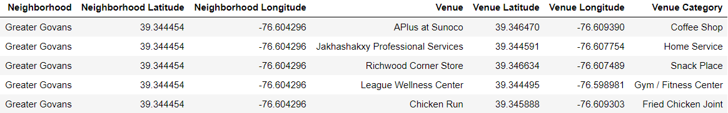

1. <https://en.wikipedia.org/wiki/Baltimore>